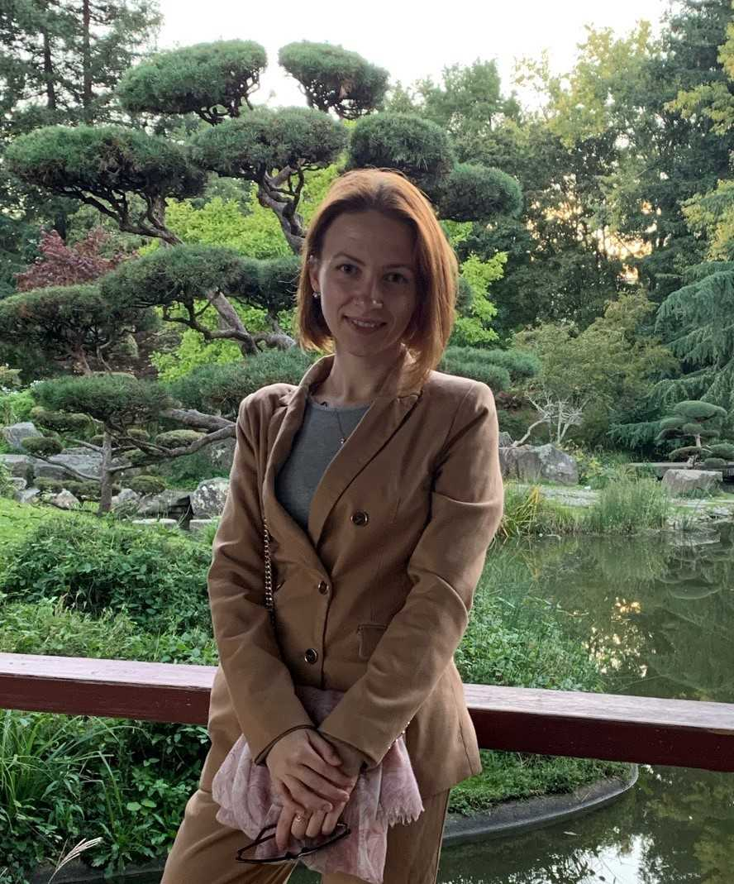
“I can say without hesitation that the Erasmus Mundus Chemical NanoEngineering program changed my life. In my opinion, it is a well-designed program that gives the opportunity to learn about different fields in “Nanoworld”. The diversity of the subjects ranging from the bioapplications of nanomaterials to nanoengineering of nanomachines in each of the three semesters of the CNE program help us to find a field we are passionate about. During the program, I discovered for myself theoretical chemistry, and also, had the possibility to see how the research work is going while working on my Master’s thesis. This helps me to decide to pursue a Ph.D. in the theoretical chemistry field and I like it a lot. Besides studies, it was a nice opportunity to meet people from over the world and make new friends as well as live in France, Poland, and Italy and discover their cultures and languages. Overall, it was a great time to be a CNE student!”
CNE Graduate Iryna Knysh

