STUDENT AGREEMENT
Erasmus Mundus Joint Master Degree in Chemical NanoEngineering

Between Aix-Marseille University, France, called ‘the University’, hereinafter referred to as the “Coordinating Institution” of the Erasmus Mundus Joint Master Degree programme, Chemical NanoEngineering (CNE), represented in the present Agreement by Prof. Philippe Knauth, as the CNE Consortium Coordinator and “First Signatory”, and

Name: ................................................................................................
First Name: ........................................................................................
Date of birth: ......................................................................................
Nationality: ........................................................................................
Country of residence: ........................................................................
Passport number: ...............................................................................

hereafter referred to as “the Student”, as the “Second Signatory”, enter into the present Agreement under the following terms and conditions:

- The Student is obliged to attend the Erasmus Mundus CNE programme, having a duration of 2 academic years, beginning on 11 September 2023, in accordance with the programme of studies supported by the European Education and Culture Executive Agency (EACEA) (https://erasmus-plus.ec.europa.eu/sites/default/files/erasmus-plus-programme-guide-2020_en.pdf) and the CNE Consortium and according to the study and mobility scheme shown in Appendix.
- The attendance referred to will be recognized by the respective CNE Consortium institutions as integral parts of the qualification for which the Student is preparing, as long as the Student is successful in the respective examinations and assessments.
- A Master thesis project may be proposed by all the partners (including Associated Partners). A certain number of subjects are also provided by the Industrial Partners. The specific quotas are defined by the Consortium Committee. The defences of the Master Thesis are public and will take place in September 2025 in Marseille.
- The Consortium universities will endeavour to deliver the joint degree and will provide the student with tuition, supervision and support services of a professional standard. They include visa and housing support, local language courses, administrative support by International Office. Students will be provided with student handbooks detailing programme and generic requirements and regulations with regard to assessment criteria, timeframes, performance thresholds and mobility arrangements.
- The Student is obliged to participate in programme’s surveys and/or evaluations.
- Students will have access to all normal student services and facilities, e.g., libraries, social services, internet, sport facilities and support services.
- In order to participate in the EMJMD CNE programme, the Student receives a scholarship granted to the EMJMD CNE Consortium by the European Commission. The different components of the scholarship depend on student’s nationality, that is, whether he/she is a citizen of one of the Erasmus+ Programme countries (i.e., Member States of the European Union (EU), North Macedonia, Iceland, Norway, Liechtenstein, Turkey, Serbia) or not (that is, the student is a citizen of any other country, called Partner country).
- The contributions to subsistence costs will be paid in maximum twenty-four monthly instalments of €1000 each to the Student bank account in France. The payments of the monthly allowance should begin up to 30 days after the beginning date stated in Article 1 of the present Agreement. However, the monthly allowance will neither be given to the scholarship holders for the periods spent during the Master (study/research/thesis) in their country of residence, nor to scholarships holders for the periods spent in any Partner Country exceeding 3 months.
- The student is also entitled to receive a contribution to travel and installation costs (destined to cover mobility costs). This amount is based on student’s place of residence as at 1 January 2023 and calculated using the European Commission’s Distance Calculator and depends on the student resident country (http://ec.europa.eu/programmes/erasmus-plus/tools/distance_en.htm).
- This contribution to travel and installation will be paid in two instalments. They will be in October 2023 and October 2024.
- In addition, the Student will receive €8000 (if citizen of a Partner country) or €4000 (if citizen of a Program country) per annum for the CNE programme participation costs (tuition fees). The Coordinating Institution will retain the annum participation costs as a tuition fee payment and will not transfer it to the Student.
- The CNE Consortium will arrange and pay for insurance cover for the duration of the programme. The CNE Consortium will organize and pay for the Summer School. Part of the participation cost will be used to pay social and cultural integration of the students. The CNE Consortium covers the costs related to issuing the diploma.
- In case of complaint, the student may appeal to the CNE Consortium Committee. The CNE Consortium Committee will consider the issue and will solve it as soon as possible. However, for specific complaint about a specific service or facility provided by a Partner Institution, the student shall invoke the complaints procedure of that institution.
- The Student shall comply at all times with all laws, regulations, codes of practice and directions issued by any competent authorities, which shall include without limitation the Aix-Marseille University and the relevant Partner Institutions/Associated Universities which are applicable to (a) the study programme being carried out by the student; or (b) the student’s presence in or on land or buildings owned, occupied or under the control of Aix-Marseille University or the relevant Partner Institutions/Associated Universities.
- The Student understands that he/she shall be excluded from the CNE programme:
i) In case of non-attendance to the CNE programme (lectures, seminars, practical sessions, information sessions, Summer School and official meetings…) that the Student cannot justify with medical certificates or for which permission has not been granted by the CNE staff (the Student should seek permission by asking in advance),
ii) If the Student is the subject of disciplinary measures leading to his/her exclusion from the CNE Coordinating Institution, Partner Institutions or Associated Universities,
iii) If the Student is the subject of legal prosecutions that prevent him/her from attending the CNE programme,
iv) If the Student withdraws from the CNE programme on his/her own decision or by force majeure.
- Any deliberate failure on the part of the Student to fulfil the conditions expected in terms of attendance at the Erasmus Mundus CNE programme, in particular non-fulfilment of the conditions stipulated in the present Agreement, constitutes sufficient reason for action to be taken towards resolving the issue and results in interruption of the scholarship.
- The Student allows their data to be used for the purposes of evaluating the programmes, efficiently manage the projects, and producing statistics. Data could be made available to the EACEA, the European Commission, the European External Action Service staff, as well as to other stakeholders of the Erasmus+ programme, such as Erasmus+ National Agencies, National Erasmus+ Offices and the Erasmus Mundus Student and Alumni Association.
- The scholarship does not create or entitle an employer-employee relation between the Coordinating Institution and the Student, and therefore is not subject to direct taxation.
- The Student is not entitled to embark on any full-time occupation with a regular salary in parallel to the studies under the Erasmus Mundus Joint Master programme.
- Any alteration to the present Agreement must be communicated in writing. All alterations to the initial situation must be immediately communicated by the Student to the Coordinating Institution. Upon mutual agreement of contractual modifications, the Coordinating Institution will issue an addendum to the present contract.
- Without prejudice to the general consequences laid down in French law applicable to the present Agreement, the Coordinating Institution reserves the right to cease the effects of the present Agreement, without recourse to any juridical procedure apart from adequate communication to the Student. Failing agreement by both parts, the French courts are designated as the only competent authorities to resolve any legal dispute emerging from the Agreement between the Coordinating Institution (Aix-Marseille University) and the Student. The present Agreement will be governed by the French law.
- The Coordinating Institution is exonerated from any responsibility for accidents, illnesses, injuries, losses or damages to persons or goods resulting from or in any way related to the activities that are the object of the present Agreement. The Student is obliged to accept the necessary insurance related to the activities for the full duration of the study period.
- The student is encouraged to join the Erasmus Mundus Students and Alumni Association (EMA) http://www.em-a.eu/
- The European Education and Culture Executive Agency (EACEA), in the
context of managing the Erasmus Mundus Joint Master Degrees, collects and processes the
personal data of some of the candidates. In particular, certain data of the scholarship holders
(students and scholars), non-scholarship holders and reserve list candidates is shared with the
Agency through the EACEA Mobility Tool and treated according to the following privacy
statement: https://eacea.ec.europa.eu/mobility/docs/privacy_statement_emt.pdf.

I, a student on the Erasmus Mundus CNE programme, solemnly swear that I will fulfil the requirements of the CNE Consortium in accordance with the Consortium’s regulations and I will conform to its discipline. Furthermore, I accept that I am responsible for commitment to, and engagement in, my learning and in other opportunities for my personal development.

I hereby confirm that I have NOT already benefited from an EMJMD scholarship.

The signatories declare that they have read and accept the conditions laid down in the present Agreement.

First signatory…………………………… Second signatory………………………………………
Prof. Philippe Knauth
CNE Consortium Coordinator

Marseille, 5 May 2023

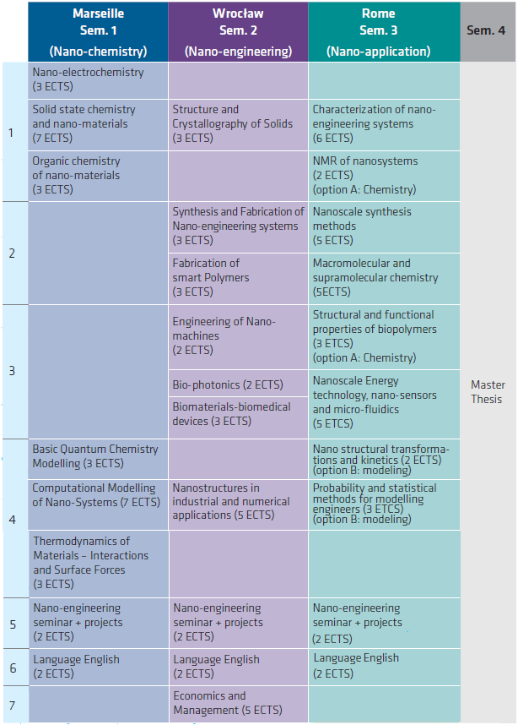
Appendix: Programme of study and mobility track

